

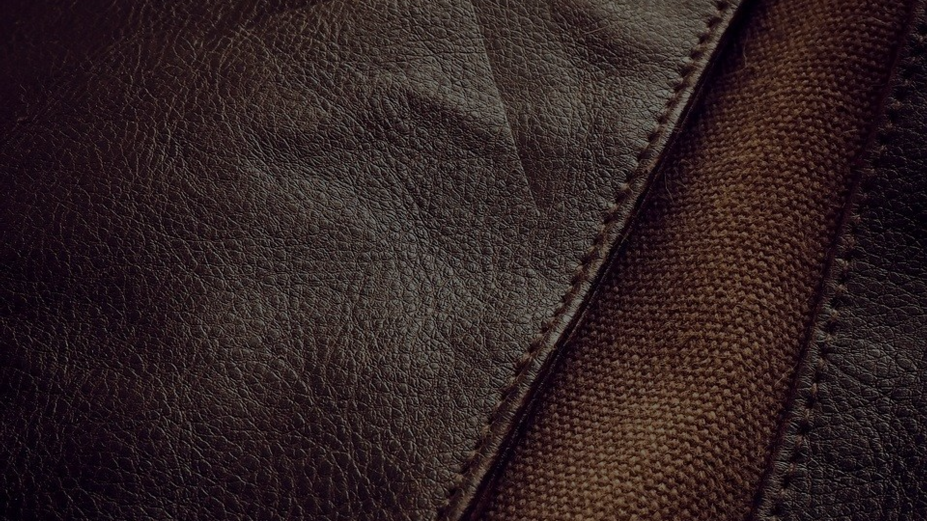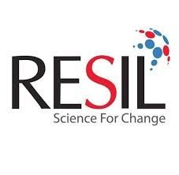

# LEATHER CHEMICALS

**Feel the softness**

**What is leather..?**

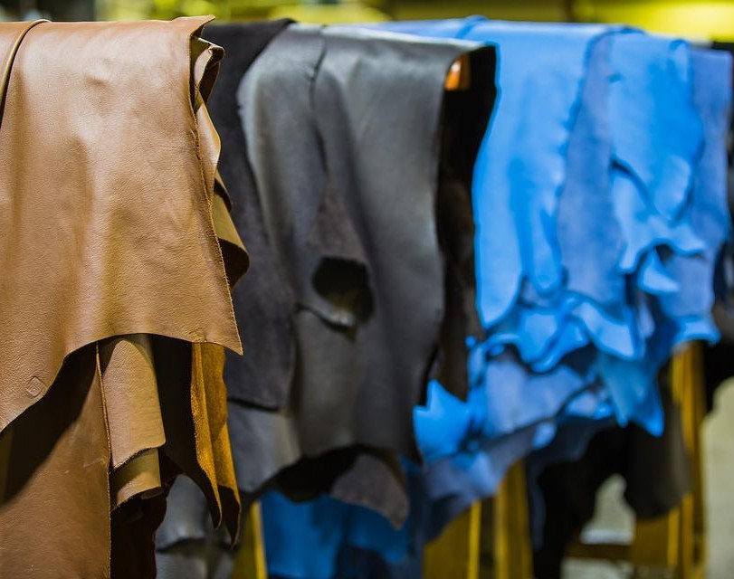

**Leather** is a durable and flexible material created by [tanning](https://en.wikipedia.org/wiki/Tanning_(leather)) animal [rawhides](https://en.wikipedia.org/wiki/Rawhide_(textile)) and skins and also by artificial means.

Types of leather:

1. Natural leather (cow, buffalo, etc)
2. Artificial leather(PVC, PU, etc)

**What is the need of silicone in leather**

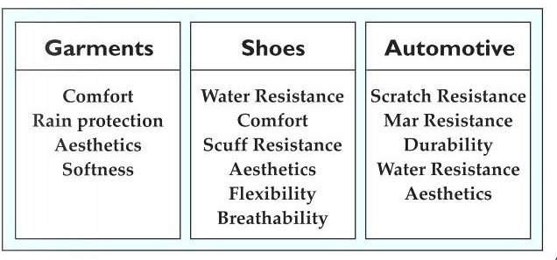**Silicones are widely used in leather due to the following properties:**

**1.Low surface tension. 2.Water resistance.**

1. **Provide soft feel 4.Durability of silicones**



**ARTIFICIAL LEATHER CHEMICALS**

* + **LEATHERSOFT MFS03**
  + **MEGAGOODFEEL MMF01& MMF02**
  + **MEGAGOODFEEL MFS0460**
  + **MEGASUPERSOFT MT10**
  + **ASF84M**
  + **MDPLF106M**

**NATURAL LEATHER CHEMICALS**

* + 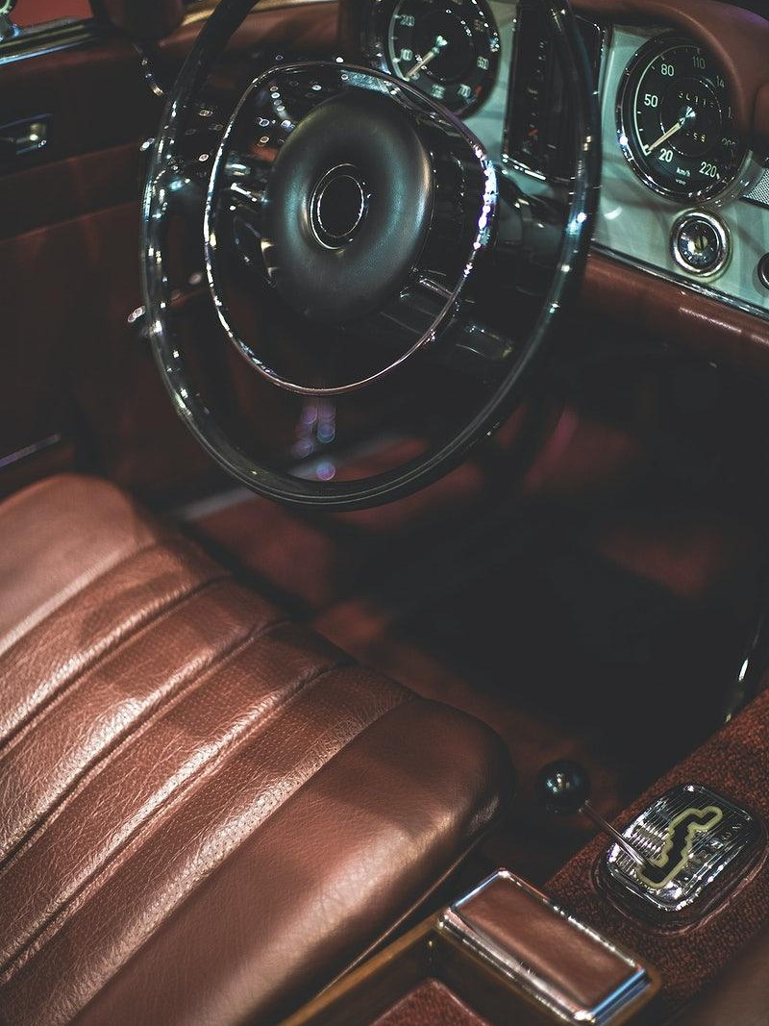**DPLF 177M**
  + **RESICARE HAS 40M**
  + **MEGAGOODFEEL FM**
  + **MEGALEATHERSOFT FS-F1M**
  + **MEGARESICARE LFM 40M**
  + **MDPLF 999M**
* **MEGALEATHERSOFT FS03M**
* **MEA20TRM**
* **MEGALEATHERSOFT FS02M**
* **MDPLF106M**
* **MEGASUPERSOFT T1&T10M**
* **MEGARESIMAX MFM**

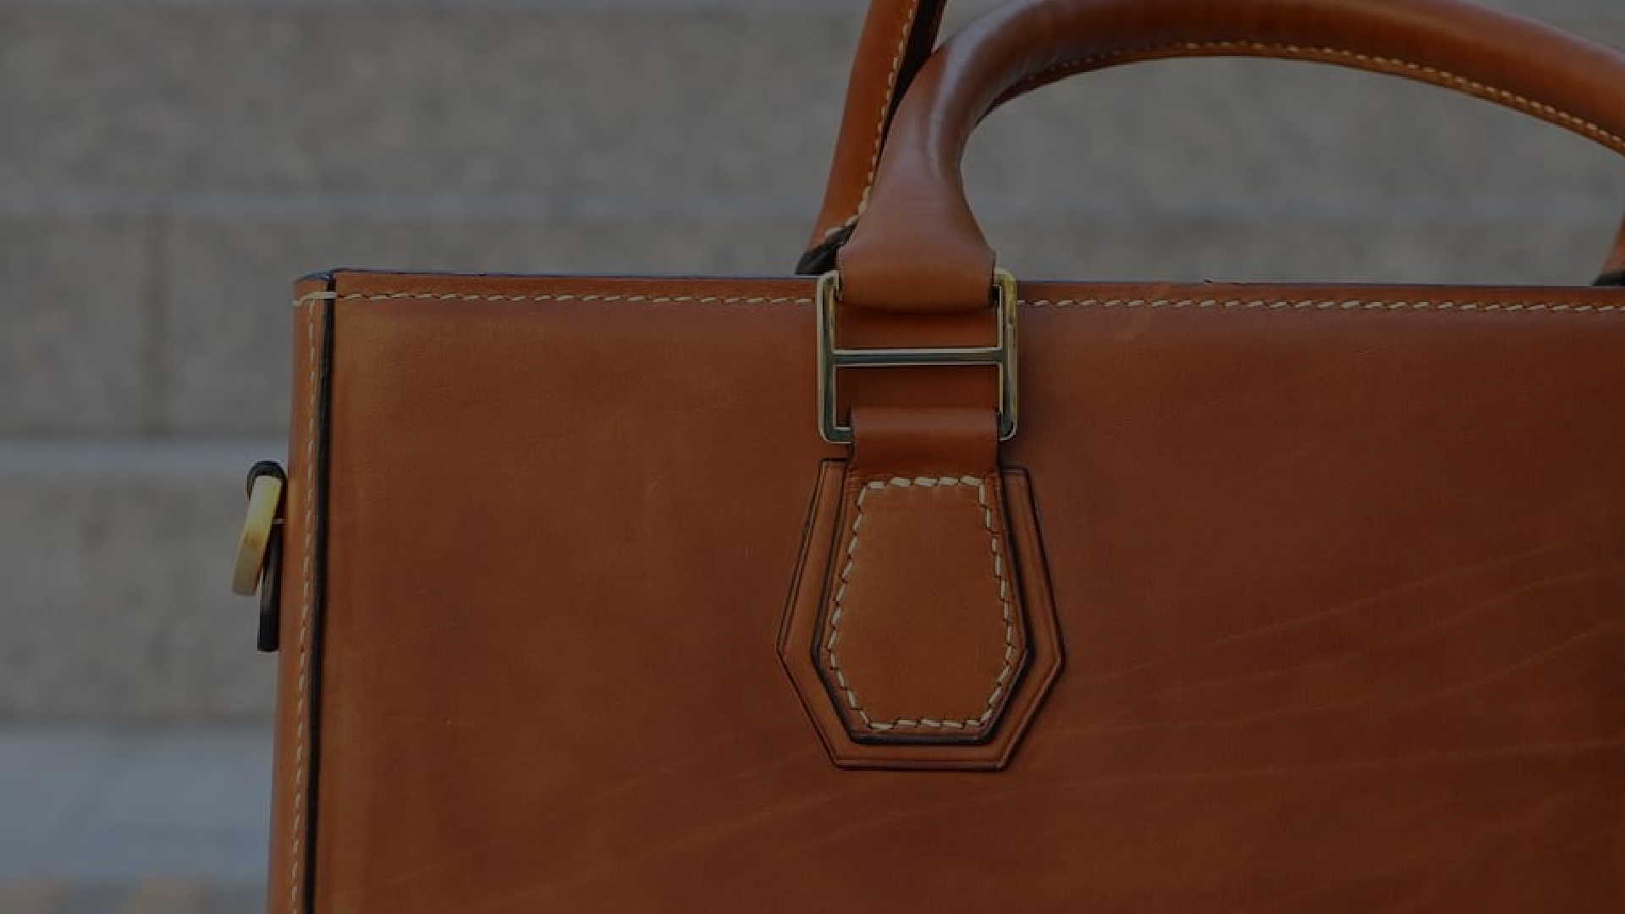

**ARTIFICIAL LEATHER CHEMICALS**

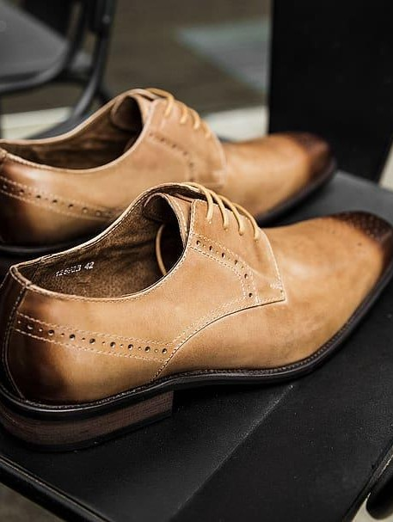

**MEGALEATHERSOFT FS03M**

MEGALEATHERSOFT FS03M is a curable amino-modiﬁed silicone resin dispersion.

It crosslinks with the surface of the leather and provides a soft and abrasion resistance to leather.

It is suitable for both natural and artiﬁcial leather. Diluent: Solvent like alcohol, ethers, etc

DOSAGE: 10-40 GPL or 0.5-1.5 wt%

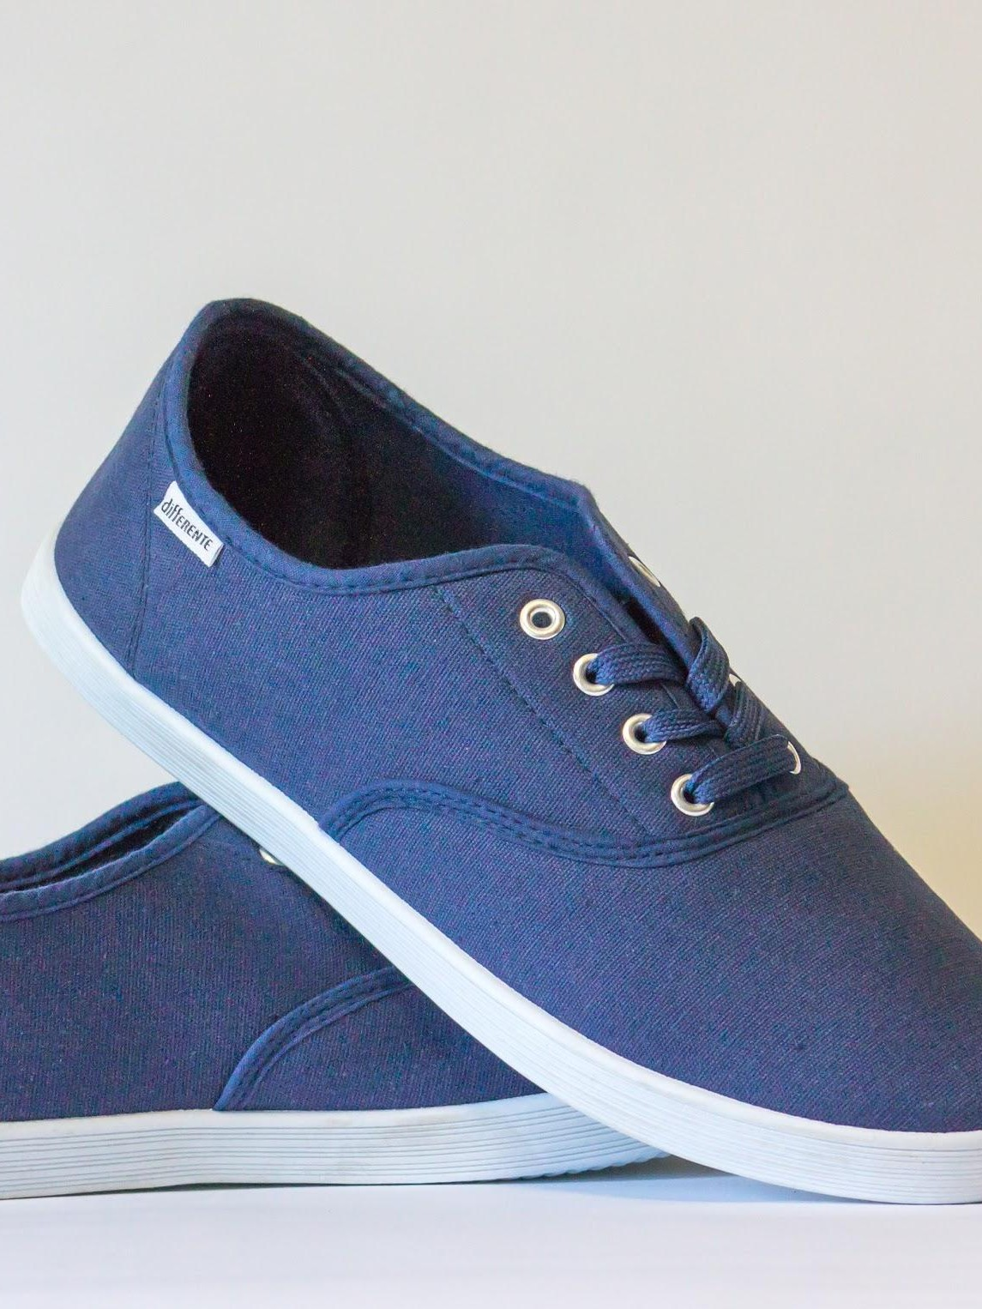**MEGAGOODFEEL FS MF-01 & 02M**

MEGAGOODFEEL FS MF01 & 02M is a non-curable high molecular weight modiﬁed silicone resin.

It provides a soft feel and sheen additive and abrasion resistance to leather.

It is suitable for artiﬁcial leather as a sprayable top coat.

Diluent: Solvent like alcohol, ethers, etc DOSAGE: MEGAFEEL FS MF-01: 2-5 wt% MEGAFEEL FS MF-02: 5-7 wt%

## MASF84M

MASF 84M is a high molecular weight amino-modiﬁed silicone resin.

It adheres to the surface of the leather and provides a soft feel and sheen additive and abrasion resistance to leather.

It is suitable for artiﬁcial leather and natural leather as a sprayable topcoat and as an additive.

Diluent: Solvent like alcohol, ethers, etc DOSAGE: 2-5 wt%

## MEGAGOODFEEL FS 0460M

MEGAGOODFEEL FS 0460M is a formulated high molecular weight amino-modiﬁed silicone resin in a solvent.

It is a non-curable resin that provides a soft feel and sheen to leather.

It is suitable for artiﬁcial leather as a sprayable topcoat and as an additive.

Diluent: Solvent like alcohol, ethers, etc DOSAGE: 3-6 wt%

## DPLF 106M

DPLF-106M is a curable amino-modiﬁed silicone resin.

It is a curable resin that provides a soft feel, water repellency, and sheen to leather.

It is suitable for artiﬁcial and natural leather as a sprayable topcoat and as an additive.

Diluent: Solvent like alcohol, ethers, etc DOSAGE: 3-5 wt%

## MEGASUPERSOFT T1M & T10M

MEGASUPERSOFT -T1M & T10M is a copolymer of polyglycol and amino-modiﬁed silicone resin.

It enhances the spreading of the other additive and provides a silky hand feel on the leather surface.

It is non-ionic in nature suitable for artiﬁcial and natural leather as a sprayable topcoat.

Active content: T1: 30% T10:60% Diluent: water.

DOSAGE: 0.5-5 wt%.



# NATURAL LEATHER PRODUCTS

## DPLF-177M

DPLF-177M is a fat liquor compatible formulated silicone emulsion.

It provides soft dry feel, imparts silky slippery and smooth touch.

It is non-ionic in nature suitable for natural leather as a sprayable topcoat in the formulation.

Diluent: water. DOSAGE: 20-30 GPL.

## MEGARESICARE HAS40M

RESICARE HAS 40 is a water based emulsion of reactive high-molecular amino-modiﬁed silicone resin.

It imparts resilience drape elastic touch and silky feel on the leather surface.

It is non-ionic in nature suitable for natural leather as a sprayable topcoat and bath additive.

Diluent: water. DOSAGE: 10-30 GPL.

## MEGAGOODFEEL FM

MEGAFEEL FM is a high molecular weight silicone dispersion.

It enhances the sheen, silky feel and provides marr resistance and abrasion resistance on the leather surface.

It is suitable for artiﬁcial and natural leather as a sprayable topcoat and formulation additive.

Diluent: water.

Active content: Approx. 60 DOSAGE: 0.5-5 wt%.

## MEGALEATHERSOFT FS-F1M

MEGALEATHERSOFT FS-F1M is a formulated emulsion of high molecular weight silicone and amino-modiﬁed silicone resin.

It provides a silky hand feel on the leather surface and ﬂexibility of the leather.

It is non-ionic in nature suitable for natural leather as a sprayable topcoat or as an formulation additive.

Diluent: water.

DOSAGE: 0.5-5 wt% 30-50 GPL.

## MEGARESIFEEL 99M

MEGARESIFEEL 99M is a high molecular weight silicone dispersion.

It enhances the sheen, silky feel and provides marr resistance and abrasion resistance on the leather surface.

It is non-ionic in nature suitable for artiﬁcial and natural leather as a sprayable topcoat and formulation additive for aqueous polyurethane or acrylic dispersion.

Diluent: water.

Active content: Approx. 70% DOSAGE: 0.5-5 wt%..

## MEGARESIMAX FM

MEGARESIMAX FM is formulated emulsion of reactive amino-modiﬁed silicone resin.

It enhances silky hand feel on the leather surface.

It is non-ionic in nature suitable for artiﬁcial and natural leather as a sprayable topcoat.

Diluent: water.

DOSAGE: 10-30 GPL, 0.5-3wt%.

## MEGARESICARE LFM 40M

RESICARE HAS 40 is a water based emulsion of reactive amino-modiﬁed silicone resin.

It enhances the shiny and silky feel on the leather surface.

It is non-ionic in nature suitable for natural leather as a sprayable topcoat.

Diluent: water. DOSAGE: 0.5-5 wt%.

## DPLF 999M

DPLF-999M is a formulated high molecular weight amino modiﬁed silicone emulsion.

It provides soft dry feel, imparts silky slippery and smooth touch.

It is non-ionic in nature suitable for natural leather as a sprayable topcoat in the formulation.

Diluent: water. DOSAGE: 20-30 GPL

## LEATHERSOFT FS02M

LEATHERSOFT FS02M is formulated silicone emulsion provides so.

It is effective at low dosage compared to the conventional silicone emulsion and enhances slickeness, outstanding soft feel on the leather surface.

It is non-ionic in nature suitable for artiﬁcial and natural leather as a sprayable topcoat as well as in the formulation.

Diluent: water. DOSAGE: 1-3 wt%.

## LEATHERSOFT FS03M

LEATHERSOFT FS03M is a curable amino-modiﬁed silicone resin dispersion.

It crosslinks with the surface of the leather and provides a soft and abrasion resistance to leather.

It is suitable for both natural and artiﬁcial leather. Diluent: Solvent like alcohol, ethers, etc

DOSAGE: 10-40 GPL or 0.5-1.5 wt%

## EA20TRM

EA20TRM is an micro emulsion of organo-modiﬁed silicone resin.

It penetrates in to the leather surface and provides the non greasy feel soft feel on the leather surface.

It is weakly cationic in nature and suitable for natural leather as a sprayable topcoat.

Diluent: water.

DOSAGE: 0.5-5%, but changes as per the hardness of water..

## DPLF 106M

DPLF-106 is a amino modiﬁed silicone resin

It is designed to impart durable silky feel to various type of leather surfaces and also for shiny ﬁnish over surface.

It is suitable for artiﬁcial and natural leather as a sprayable topcoat.

Diluent: solvent. DOSAGE: 3-5 wt%.

## SUPERSOFT T1M & T10M

SUPERSOFT -T1 & T10 is a copolymer of polyglycol and amino-modiﬁed silicone resin.

It enhances the spreading of the other additive and provides a silky hand feel on the leather surface.

It is non-ionic in nature suitable for artiﬁcial and natural leather as a sprayable topcoat.

Active content: T1: 30% T10:60% Diluent: water.

DOSAGE: 0.5-5 wt%.





Address:

19,Mohini Mohan Road

Kolkata-700020

Contact Number:

Mobile Nn : +919830377242

Phone Nn : 7980286087

Email id:meeraki.chem@gmail.com